VASAVI COLLEGE OF ENGINEERING (AUTONOMOUS)
IBRAHIMBAGH, HYDERABAD-31
Department of Computer Science and Engineering

Name of the Course: Data Mining
Quiz – I

Name of the Faculty: D.Laxmiprasanna Date : 03/09/2024
Class: B.E. 4/4 -A Sem: VII

Q.no | Description of the question | Marks | Blooms Taxonomy | Mapped
 |  |  |  | CO | PO
1 | Consider the following two document vectors and find the similarity using Cosine measure  d1 = 6 2 0 0 6 0 0 3 0 0  d2 = 3 0 0 2 0 5 0 1 0 2 | 1 | 3 | 1 | 1,2
2 | Find the variance and standard deviation for the data given below 6, 3, 8, 5, 3,7,2,9,1,2,4,2,7,9 | 1 | 3 | 1 | 1,2
3 | 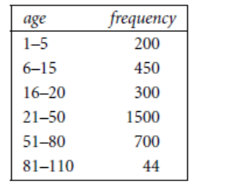  Compute approximation median value for group 6-15 | 1 | 3 | 1 | 1,2
4 | Compute the Jaccard Coefficient for the following binary objects O1= (1,1,0,0,0,1,0,0,1,0) O2= (0,1,0,0,0,1,0,1,0,0) | 1 | 3 | 1 | 1,2
5 | Draw a Boxplot for the data given as 85,92,78,88,90,88,89 | 1 | 3 | 1 | 1,2
6 | Compute the cosine similarity between document1, document2 and document2, document4 | 1 | 3 | 1 | 1,2
   | K1 | K2 | K3 | K4 | K5 | K6 | K7
  D1 | 5 | 0 | 3 | 0 | 2 | 0 | 0
  D2 | 3 | 0 | 2 | 0 | 1 | 1 | 0
  D3 | 0 | 7 | 0 | 2 | 1 | 0 | 0
  D4 | 0 | 1 | 0 | 0 | 1 | 2 | 3
7 | Suppose your midterm test score is 83 and your final exam score is 95. Using weights of 40% for the midterm and 60% for the final exam, compute The weighted average of your scores.  If the minimum average for an A is 90, will you earn an A? | 3 | 3 | 1 | 1,2
8 | Consider the attributes Age (X) and Glucose Level (Y) as given in the table. Find the relation between X and Y  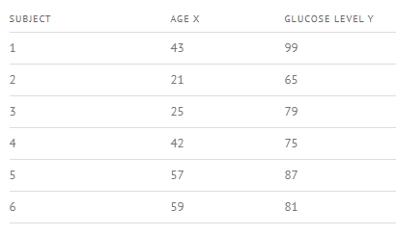 | 3 | 3 | 1 | 1,2
9 | Suppose that a hospital tested the age and body fat data for 18 randomly selected adults  with the following results:  (a) Calculate the mean, median, and standard deviation of age and %fat.  (b) Draw the boxplots for age and %fat.  (c) Draw a scatter plot and a q-q plot based on these two variables. | 4 | 3 | 1 | 1,2
  age | 23 | 23 | 27 | 39 | 41 | 47
  %fat | 9.5 | 26.5 | 7.8 | 17.8 | 31.4 | 25.9
  age | 49 | 52 | 54 | 54 | 56 | 58
  %fat | 27.2 | 34.6 | 42.5 | 28.8 | 30.2 | 34.1
10 | Normalize the age attribute values 3,15,16,19,20,21,22,22,25,25,25,25,30,33,33,35,35,35,35,36,40,45,52,70 using Min-Max Normalization (New min=0, New max=1) and Z-Score normalization. | 4 | 3 | 1 | 1,2

